ASSIGNMENT 29

Name : Akanksha Joshi

Roll No : B038

Batch : 3

Div : BTech CS B

--------------------------------------------------------------------------------------------------------------------------

Consider the pseudo code for generating Fibonacci series using Recursion:

FIBO (number)

1.

if (number = 0) then

2.

return (0)

3.

else if (number = 1) then

4.

return (1)

5.

else

6.

return FIBO(number - 1) + FIBO(number - 2)

7.

end if

Write a program in Python to implement the same using Recursion and execute it in Eclipse. Print appropriate error

message if the user enters negative number as input.

Duration : 10 mins

Source Code

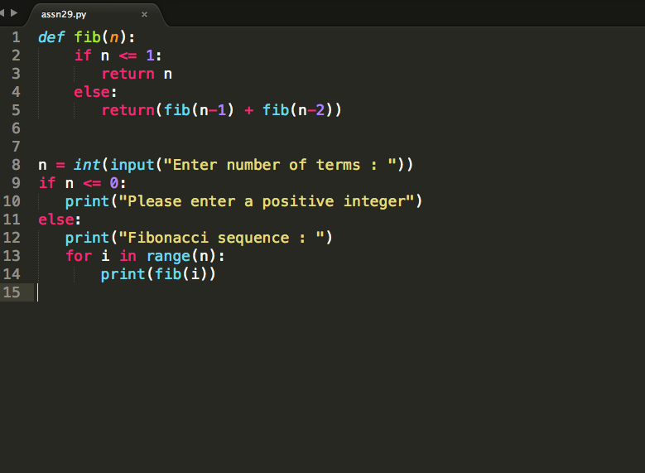

Output

Enter number of terms : 10

Fibonacci sequence :

0

1

1

2

3

5

8

13

21

34